EXPERIMENT-11
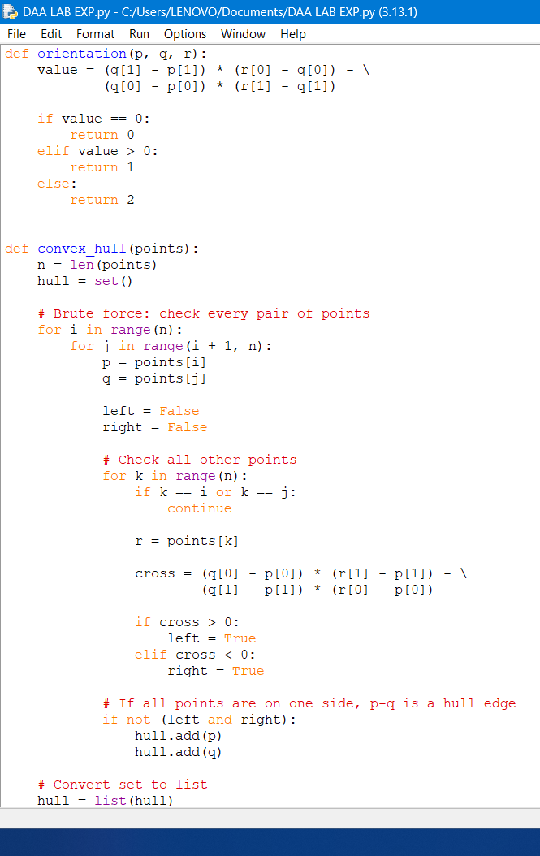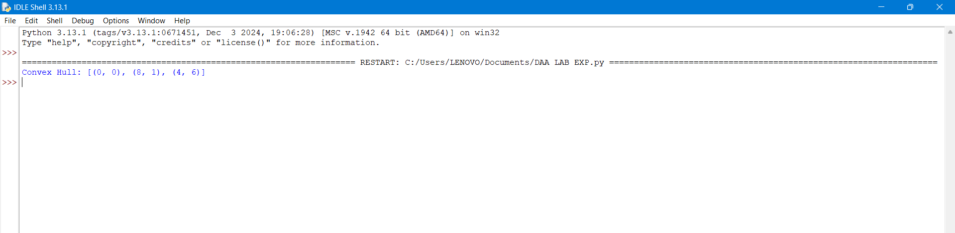
For the brute-force Convex Hull algorithm:
Time Complexity: O(n³)
Reason:
- Choose every pair of points → O(n²)
- For each pair, check all other points → O(n)
- Therefore:
O(n²) × O(n) = O(n³)
The final sorting of hull points takes O(h log h), where h ≤ n, so it doesn't dominate the O(n³) brute-force process.
Space Complexity: O(n)
- We store the convex hull points → at most n points.
- Therefore, auxiliary/output space is O(n).
Final Answer
Complexity | Value
Time Complexity | O(n³)
Space Complexity | O(n)
Best line to write in your record/exam:
The brute-force convex hull algorithm has O(n³) time complexity and O(n) space complexity.
EXPERIMENT-12

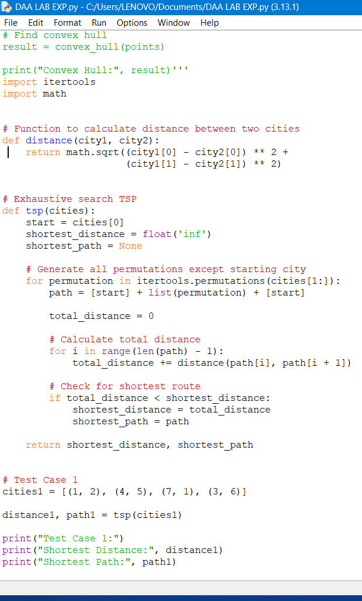
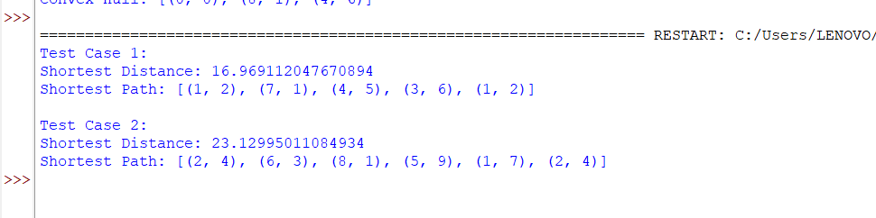
For the TSP using Exhaustive Search:
Time Complexity: O(n! × n)
Reason:
- Number of possible permutations = (n − 1)!
- For each permutation, we calculate the total route distance by checking n cities.
- Therefore:
O((n − 1)! × n) = O(n!)
So, the commonly stated time complexity is:
O(n!)
Space Complexity: O(n)
- Store each permutation/path → O(n)
- Store the shortest path → O(n)
- itertools.permutations() generates permutations one at a time rather than storing all of them.
Space Complexity = O(n)
Final Answer
Complexity | Value
Time Complexity | O(n! × n) ≈ O(n!)
Space Complexity | O(n)
For your record:
The exhaustive-search TSP algorithm has O(n! × n) time complexity and O(n) space complexity.
EXPERIMENT-13
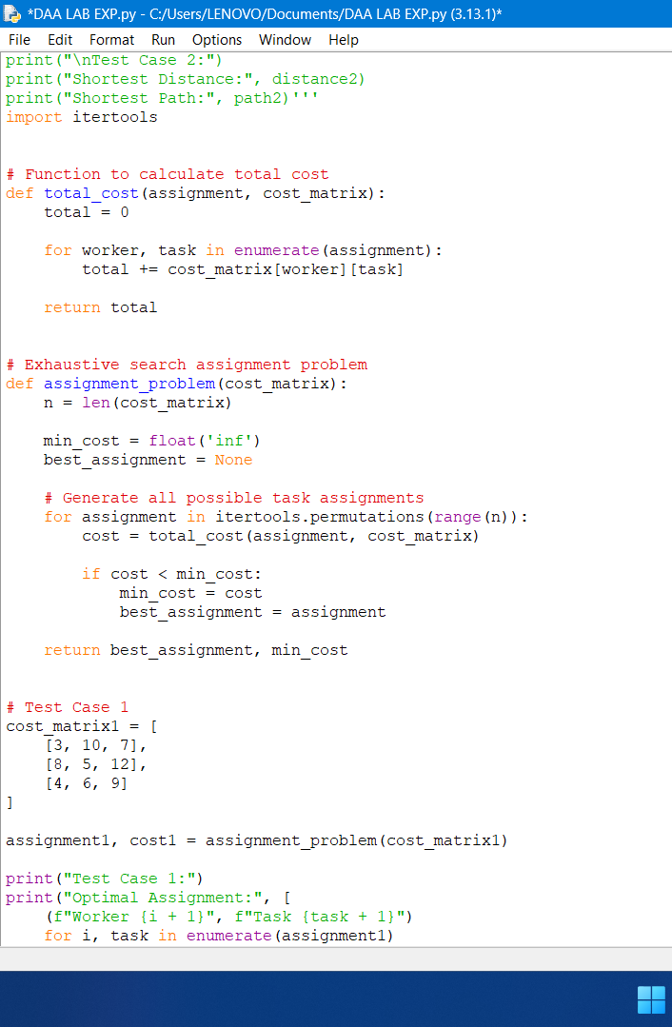
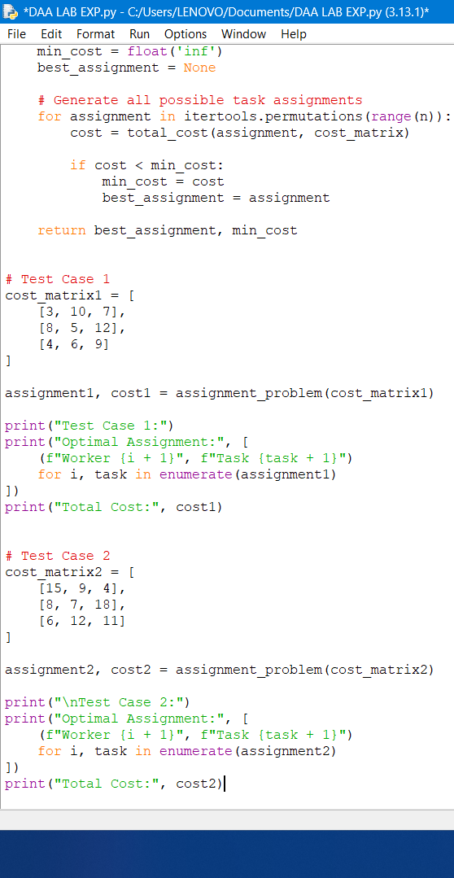
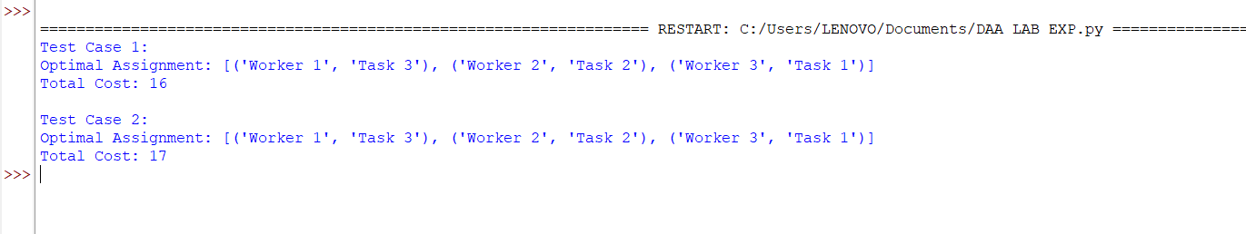
Time Complexity
There are n! permutations of task assignments.
For each permutation, calculating the total cost requires O(n) operations.
Therefore:
Time Complexity = O(n × n!)
Commonly written as O(n!) for exhaustive-search assignment problems, but O(n × n!) is the more precise complexity for this implementation.
Space Complexity
The algorithm stores:
- Current assignment → O(n)
- Best assignment → O(n)
- itertools.permutations() generates permutations one at a time.
EXPERIMENT-14
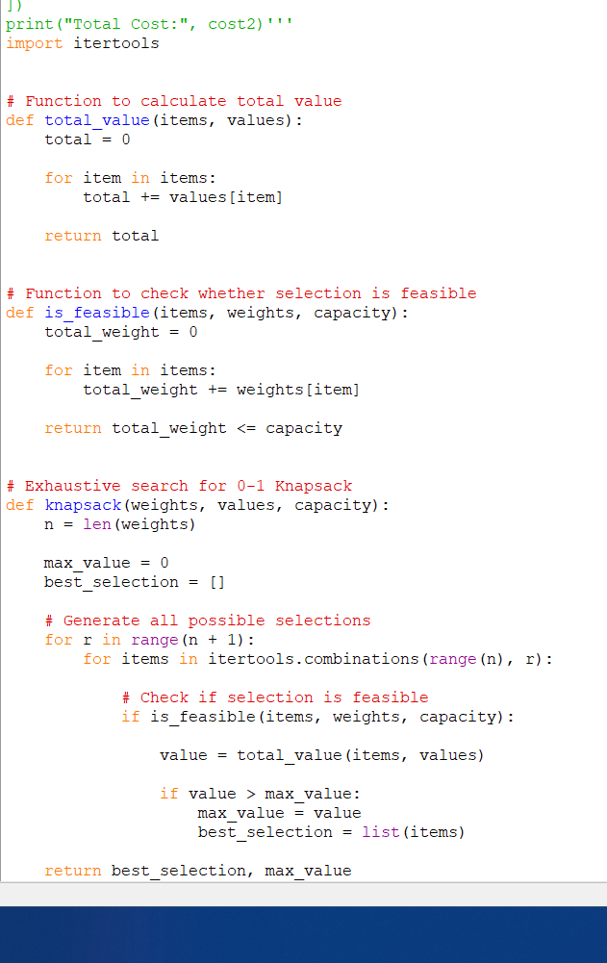
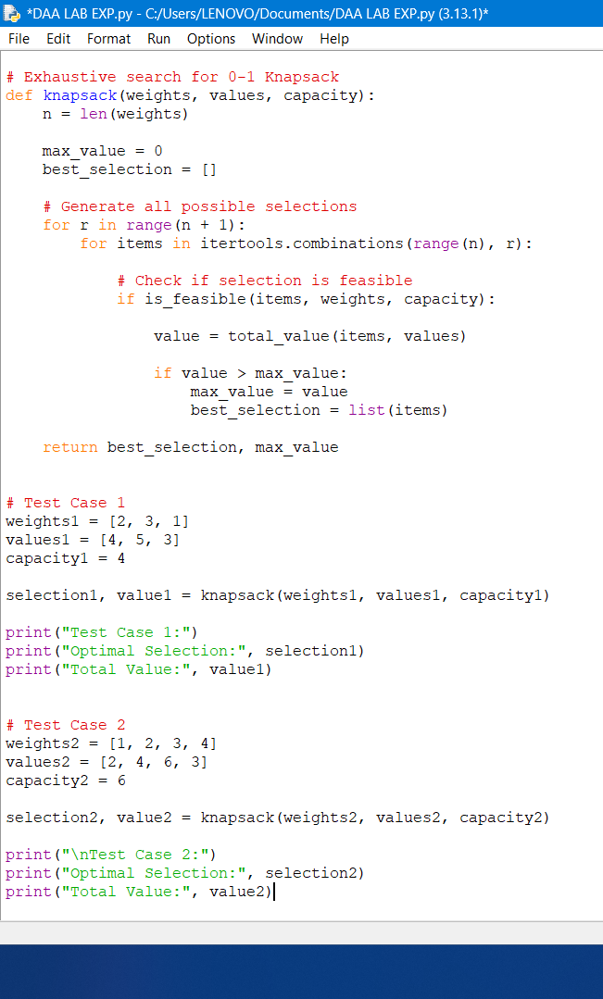
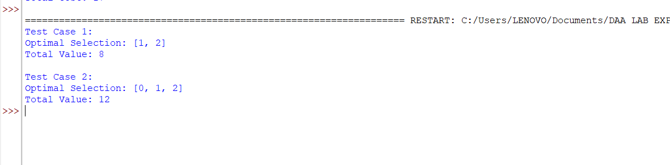

Time Complexity
For n items, there are 2ⁿ possible subsets.
For every subset:
- Check feasibility → O(n)
- Calculate total value → O(n)
Therefore:
Time Complexity = O(n × 2ⁿ)

Space Complexity
The algorithm stores the current/best selection of items, which requires at most O(n) space.
itertools.combinations() generates combinations one at a time.
Therefore:
Space Complexity = O(n)
Final Answer
Complexity | Value
Time Complexity | O(n × 2ⁿ)
Space Complexity | O(n)
The exhaustive-search 0-1 Knapsack algorithm has O(n × 2ⁿ) time complexity and O(n) space complexity.
EXPERIMENT-15
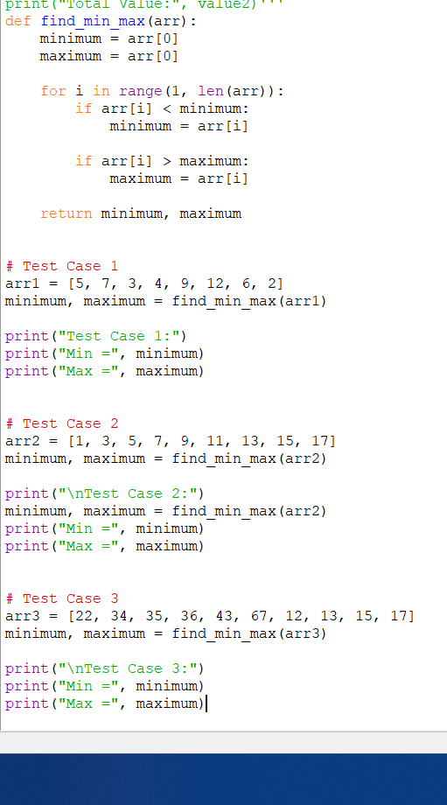
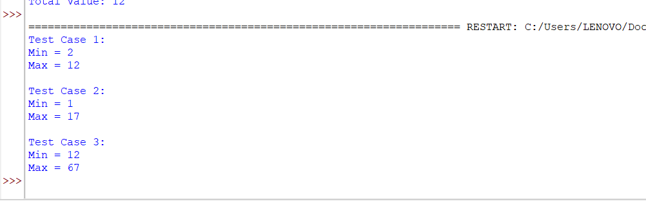
Time Complexity
The program traverses the array once.
For N elements:
Time Complexity = O(N)
Space Complexity
Only two variables, minimum and maximum, are used.
Space Complexity = O(1)
EXPERIMENT 16
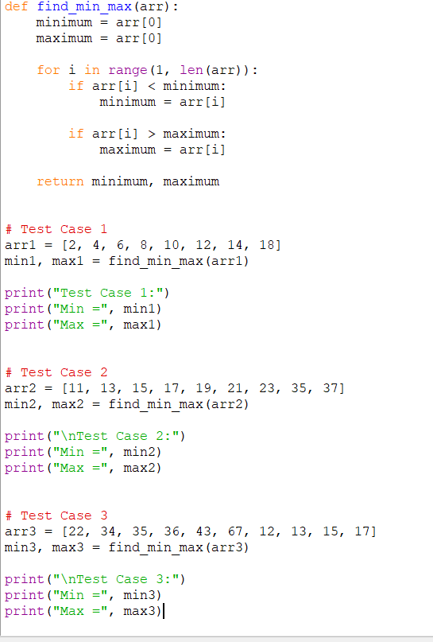
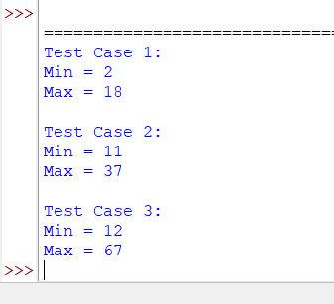
Time Complexity
The program checks every element once.
Time Complexity = O(N)
Space Complexity
Only two extra variables (minimum and maximum) are used.
Space Complexity = O(1)
EXPERIMENT-17
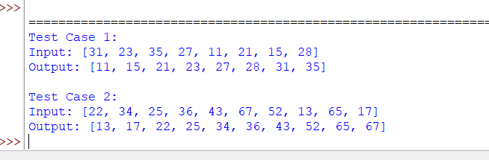
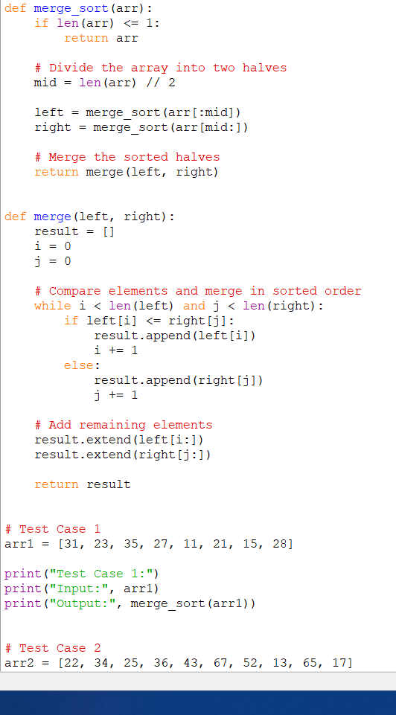
Time Complexity
- Dividing the array takes O(log N) levels.
- Merging at each level takes O(N).
Therefore:
Time Complexity = O(N log N)
Space Complexity
The temporary arrays created during merging require:
Space Complexity = O(N)
EXPERIMENT-18
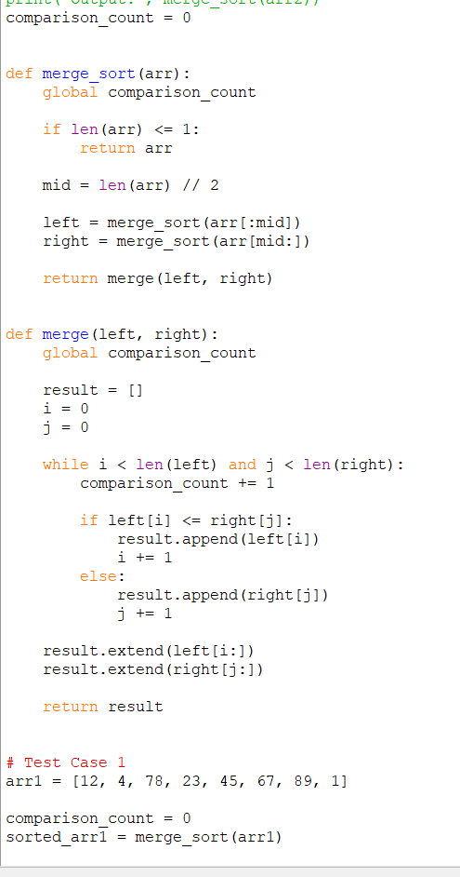
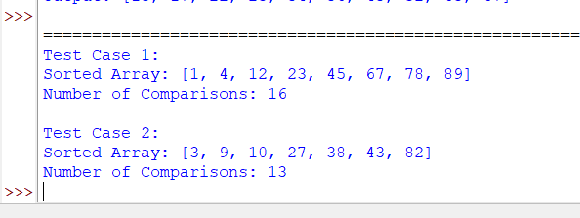
Time Complexity
Merge Sort divides the array into halves and merges them.
Time Complexity = O(N log N)
Space Complexity
Temporary arrays are used during merging.
Space Complexity = O(N)
EXPERIMENT-19
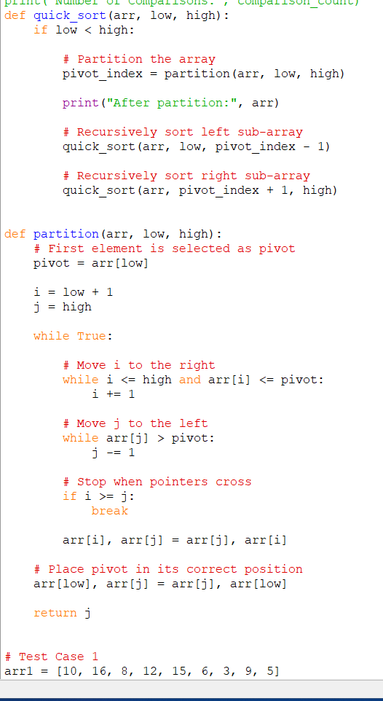
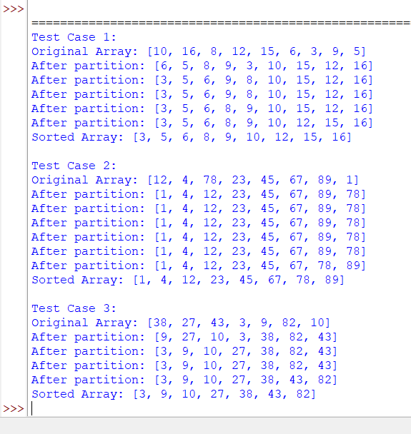
Time Complexity
Case | Time Complexity
Best Case | O(N log N)
Average Case | O(N log N)
Worst Case | O(N²)
Since the first element is always selected as pivot, an already sorted or nearly sorted array can produce the worst case.
Space Complexity
- Average recursion depth: O(log N)
- Worst-case recursion depth: O(N)
Therefore:
Average Space = O(log N)
Worst-case Space = O(N)
EXPERIMENT 20
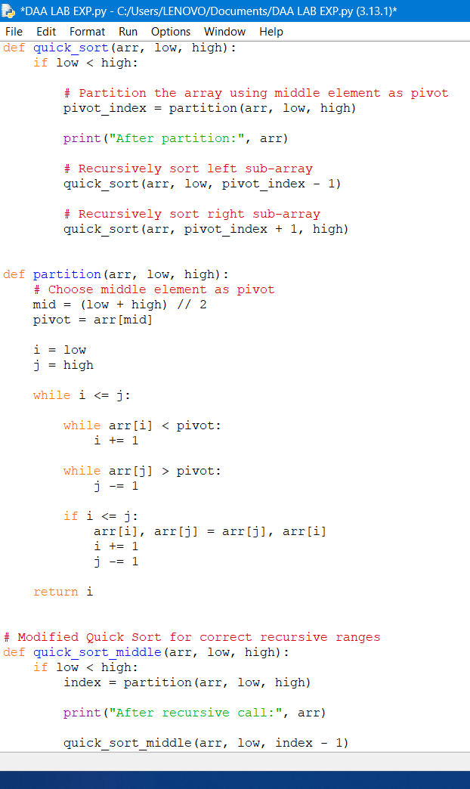
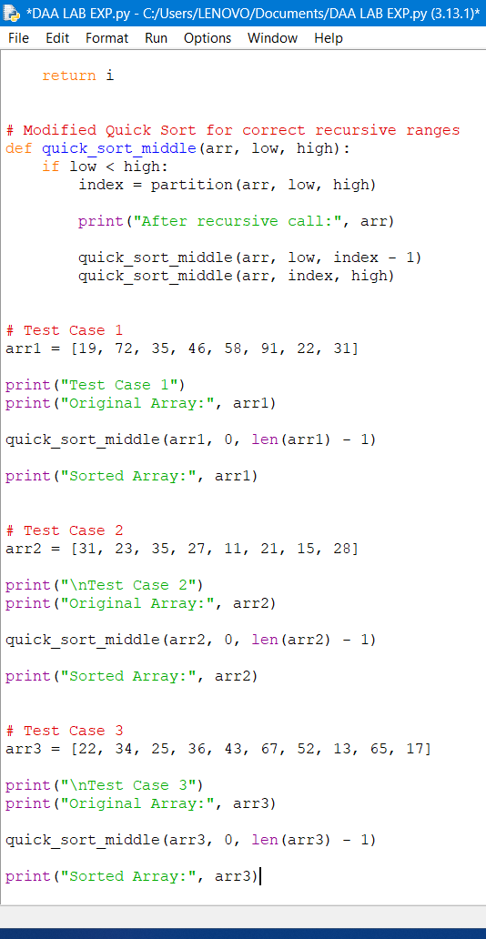
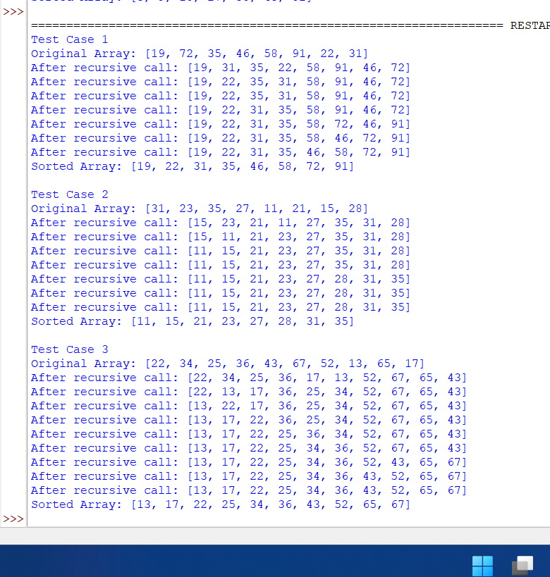
Complexity
Case | Time Complexity
Best Case | O(N log N)
Average Case | O(N log N)
Worst Case | O(N²)

Space Complexity:
- Average: O(log N)
- Worst: O(N)

